LITANY TO SAINT ELIZABETH SETON
Elizabeth, loving daughter:
encourage in all children obedience and love.
Elizabeth, troubled teenager:
speak to today’s confused, sometimes abused
young people.
Elizabeth, faithful wife:
grant gifts of love and generosity to all spouses.
Elizabeth, caring mother:
share your mother’s heart with all parents.
Elizabeth, grieving widow:
look with compassion on all bereaved wives.
Elizabeth, loyal friend:
teach us to share friendship generously.
Elizabeth, heroic searcher of truth:
guide all who, with fear and doubt, seek the way.
Elizabeth, courageous convert:
strengthen the newly baptized
as they embrace the faith.
Elizabeth, sorrowing mother:
console those parents suffering the loss of a child.
Elizabeth, steadfast religious:
inspire young women to follow in your path.
Elizabeth, inspired educator:
share your gifts with all teachers.
Elizabeth, a woman for all women:
bestow your charism of love and service
on all women today.
- Sr. M. Irene Fugazy, SC (NY)

Sisters of Charity of New York
6301 Riverdale Avenue, Bronx, NY 10471
718.549.9200
www.scny.org

SAINT ELIZABETH ANN BAYLEY SETON
1774-1821

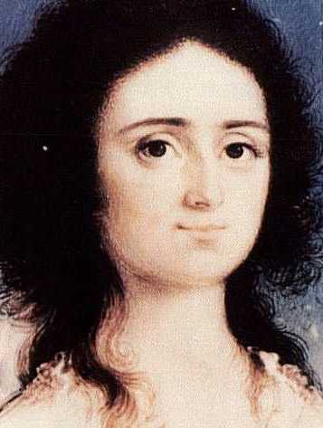



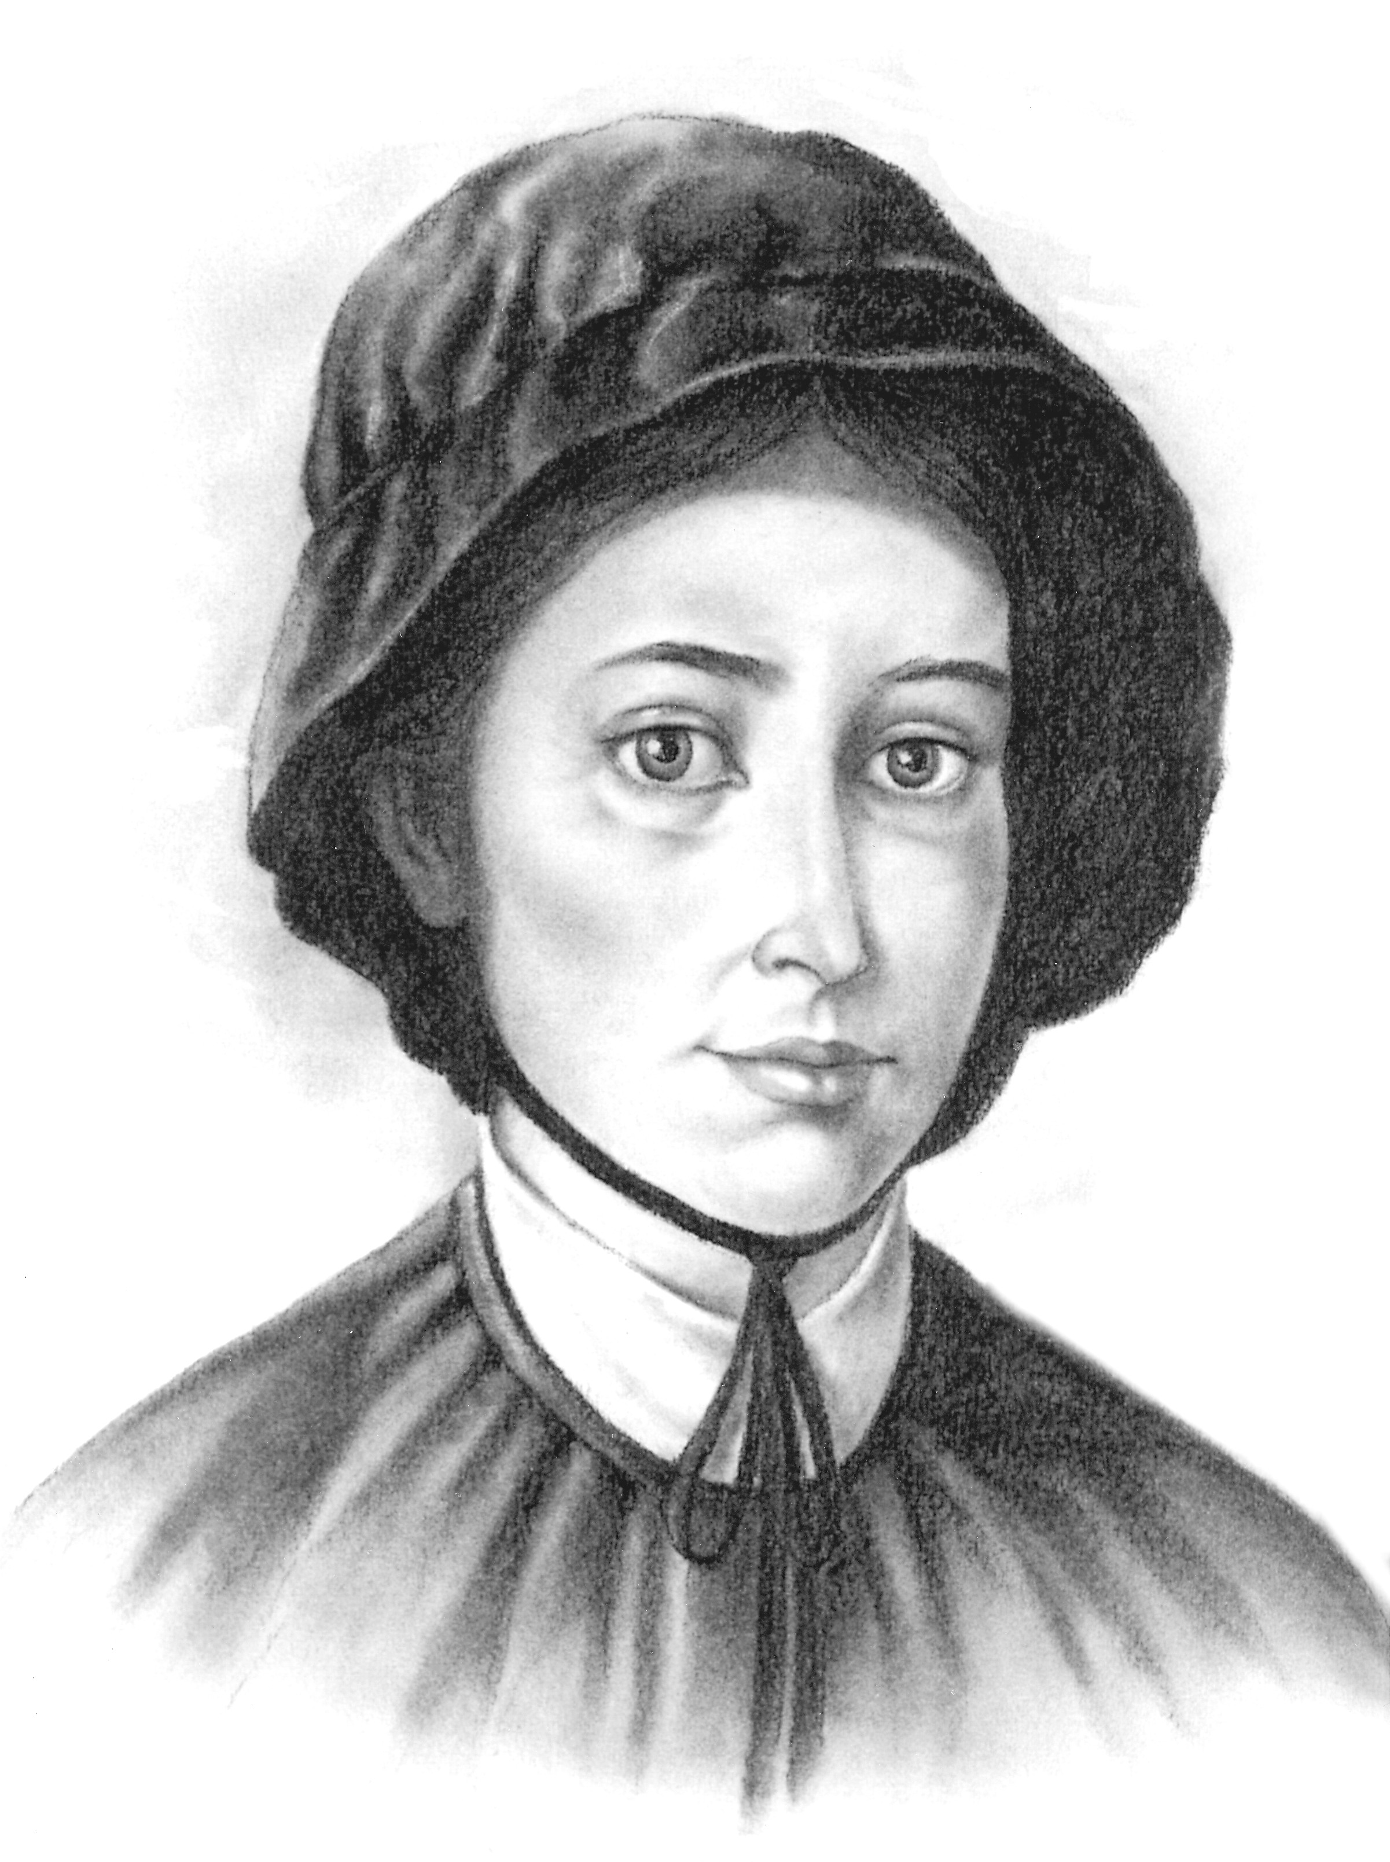
St. Elizabeth Ann Seton’s Story
Elizabeth Ann Bayley Seton was the first native born American Saint. She was born in colonial New York in 1774 just before the American Revolution. A very sad thing happened to Elizabeth when she was only three. Her mother died. Her father, Dr. Richard Bayley was New York City’s chief Health Officer and he was so busy taking care of the sick that sometimes he forgot about Elizabeth and her sister, Mary. Dr. Bayley married again, and his new wife gave more attention to her own children than to Elizabeth and Mary, so they traveled to relatives either in New Rochelle or Staten Island. At the age of nineteen Elizabeth met William Magee Seton, the oldest son of a famous New York family. William and Elizabeth fell in love, and they were married on January 25, 1794. The early years of their marriage were spent in the fashionable Wall Street section of Manhattan where Elizabeth at last had a home of her own. Elizabeth and William had five children, three girls and two boys. Elizabeth was very happy. She had everything she had ever wanted, her own home, children, and a loving husband. She also thought of other people and with other women founded the Widows’ Society of New York which took care of families whose fathers had died.
Suddenly, Elizabeth’s life began to change. William Seton’s father became ill and died. Elizabeth and her husband, William had to assume responsibility for eight children who were already motherless. They moved from their own home to care for the Seton children. The Seton business failed, and William Seton had to declare bankruptcy. William and Elizabeth sold their home and sadly watched as their beautiful furnishings and possessions were

sold. In 1801, Elizabeth’s father, Dr. Bayley died during the Yellow Fever Epidemic. Elizabeth’s husband William became ill with a disease called tuberculosis. Because William was so sick, Elizabeth planned a trip to Italy hoping that the mild climate would save his life. Leaving four of her young children with relatives, she sailed to the home of the Fillichi’s, business friends of the Setons. Elizabeth’s beloved William died in Italy at the home of Antonio and Filippo Filicchi.
As sad as she was, Elizabeth was inspired by the Catholic Faith of the Filicchi family. She was especially impressed that they believed in the real presence of Jesus in the Eucharist. Elizabeth had been an Episcopalian and Episcopalians did not believe that Jesus was really present in the Eucharist. Elizabeth became a Catholic when she returned to New York. Elizabeth and her children sailed to Baltimore, the largest city in Catholic Maryland. In Baltimore, she opened a school at the request of Father William Dubourg, President of St. Mary’s College. Elizabeth was asked to start a group of Religious sisters. On March 25, 1809, Elizabeth and the young women who had joined her pronounced special promises to God called vows. From that day forward, she was known as Mother Seton. Soon, Elizabeth, sixteen Sisters and a school moved into a house in Emmitsburg, Maryland. The community and the school kept growing and growing. This school, St. Joseph Academy, was the beginning of Catholic parochial education in America. Mother Seton died on January 4, 1821, but not before sending Sisters to establish schools and orphanages in Philadelphia and New York. Elizabeth Seton was a loving wife and mother, founder of the first group of American Sisters and the parochial school system. She belongs to all of us.

